Year 5 Reading and Writing Long Term Plan: 2024-2025
Tudors/Settlement and Land Use | Mayans/Amazonia | Greeks/Earthquakes and Volcanoes
Autumn 1  7 weeks |  | Autumn 2  7 weeks |  | Spring 1  6 weeks |  | Spring 2  6 weeks |  | Summer 1  5 weeks |  | Summer 2  8 weeks
Novel to read: Fortunately, the Milk |  | Novel to read: Harry Potter and the Philosopher’s Stone |  | Novel to read: Journey to the River Sea |  | Novel to read: Oh Maya Gods! |  | Novel to read: Percy Jackson and the Greek Gods. |  | Novel to read: Podkin One-Ear / Kensuke’s Kingdom
WRITING | READING | WRITING | READING | WRITING | READING | WRITING | READING | WRITING | READING | WRITING | READING
Writing Learning Journey 1: (3 weeks)  The Clocktower  by  Genre:  Themes:  Audience:  Form:  Effect:  SOA: | Reading Learning Journey 1: (3 weeks)  Fortunately, the Milk  by Neil Gaiman  Genre: Fiction  Focus skills: Select and retrieve  Themes: Voyage and Return.  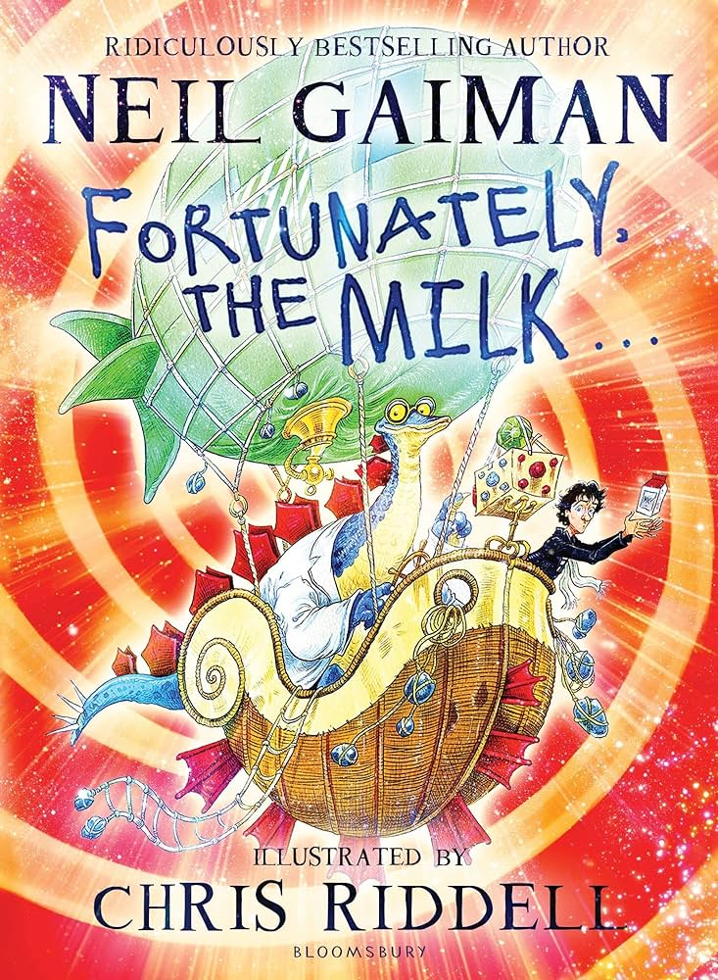 | Writing Learning Journey 1: (3 weeks)  Winter’s Child  by Angela McAllister  Genre: Fiction/fantasy  Themes: Friendship, winter, family, mythical  Audience: Fans of the book  Purpose: to entertain  Form: Setting and Character Description.  Effect: Readers are transported to the world of the story.  SOA:  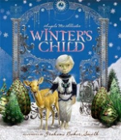  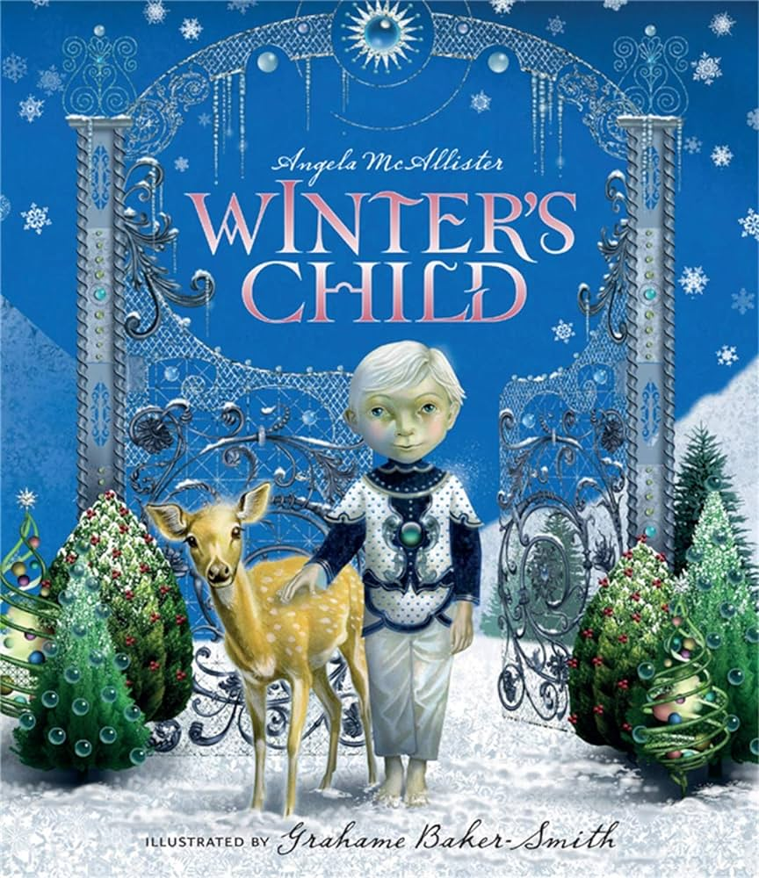 | Reading Learning Journey 1: (3 weeks)  The Incredible Ecosystems of Planet Earth  by Rachel Ignotofsky  Genre: Non-fiction  Focus Skills:  Themes: Truth  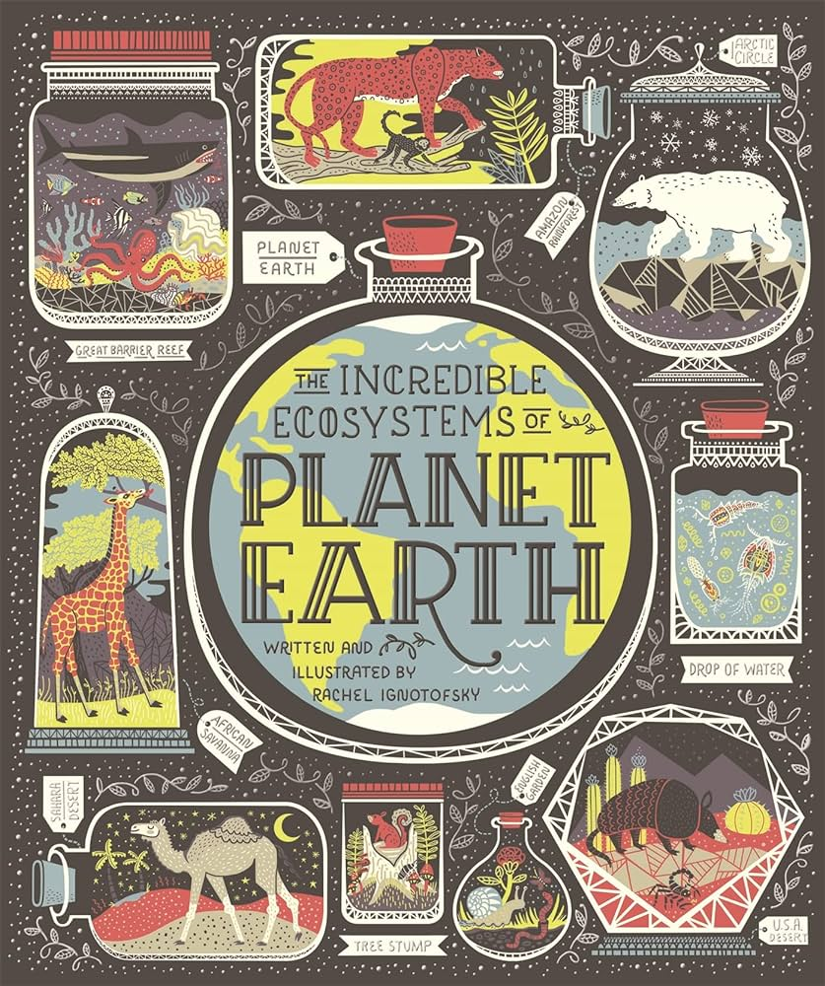 | Writing Learning Journey 1: (3 weeks)  Quest  by Aaron Becker  Genre: Fantasy  Themes: Good vs evil, Heroism, Overcoming the monster.  Audience: Children  Purpose: To entertain.  Form: Narrative.  Effect:  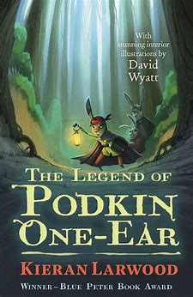  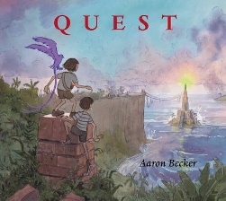  SOA:  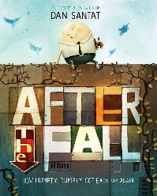  Quest from the Journey trilogy by Aaron Becker - Score by Rob Davies performed by NotePerformer 3 (youtube.com) | Reading Learning Journey 1: (6 weeks)  Survivors  by David Long  Genre: Non-fiction  Focus skills: Respond and Explain, Clarify  Theme: Survival, Courage  Each week focuses on a different story from the book.  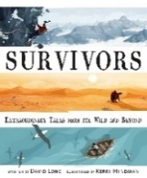  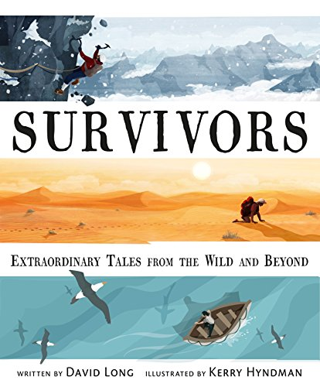 | Writing Learning Journey 1: (3 weeks)  The Majestic Plastic Bag  Genre: Mockumentary  Themes: plastic pollution, voyage and return, environmentalism, caring for the environment.  Audience: The public  Purpose: To raise awareness  Form: Recount from the bag’s POV  Effect: Viewers take action  SOA:  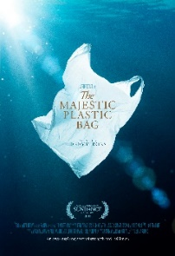 | Reading Learning Journey 1: (4 weeks)  Oh Maya Gods!  by Maz Evans  Genre: Fiction (historical)  Focus skills: Inference, clarify.  Theme: Survival, accepting differences  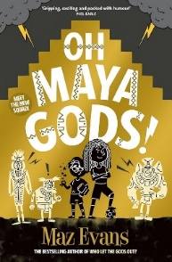 | Writing Learning Journey 1: (3weeks)  Percy Jackson and the Greek Gods  by Rick Riordan  Audience:  Purpose:  Form: Non-chronological report (Hades / Underworld creature)  Effect:  SOA:  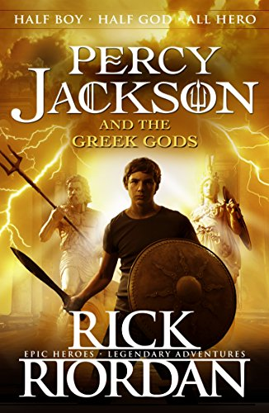 | Reading Learning Journey 1: (3 weeks)  Malala: My Story of standing up for girls’ rights  by Malala Yousafzai  Genre: Non-Fiction (autobiography))  Focus skills: Summarise,  Clarify  Theme: Heroism, courage, good vs evil.  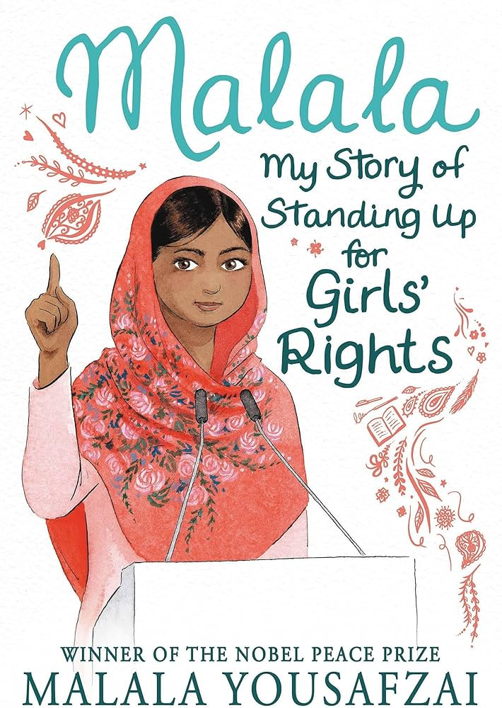 | Writing Learning Journey 1: (3 weeks)  A Stage Full of Shakespeare Stories by Angela McAllister  (Supported by BBC Teach Videos - Midsummer Night’s Dream)  Genre: Historical Fiction/Heritage  Themes: Heritage, good vs. evil  Audience: Fans of Shakespeare  Purpose: To entertain  Form: Narrative  Effect:  SOA: Setting / Character Description  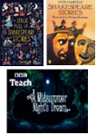 | Reading Learning Journey 1: (2 weeks)  Tales from Outer Suburbia  by Shaun Tan  Focus on two stories: Night of the Turtle Rescue and No Other Country  Genre: Fiction  Focus skills:  Theme: Accepting differences, courage, voyage and return  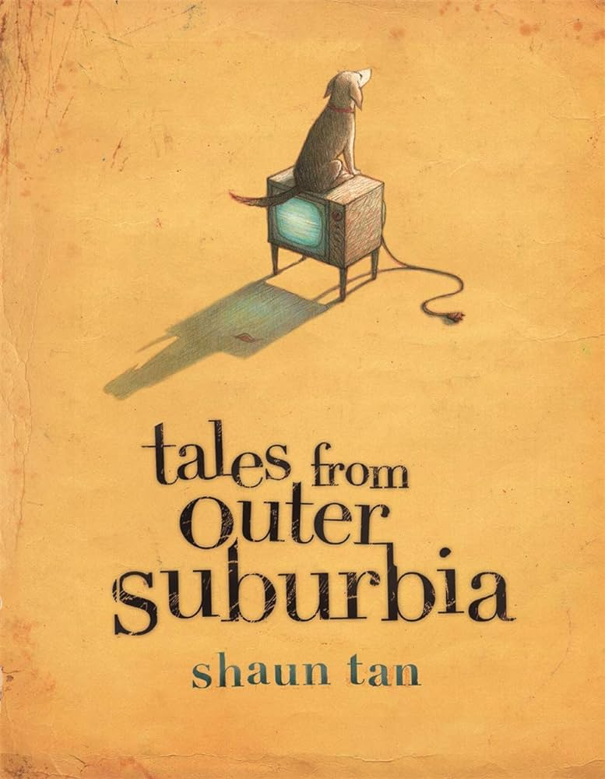
Writing Learning Journey 2: (3 weeks)  After the Fall by Dan Santat  Genre: Fiction  Themes: Courage, Fear  Audience: Blog readers  Purpose: Reflection/  Persuasion  Form: Blog Post  Effect:  SOA: Diary entry from Humpty’s perspective  → GD from King’s man perspective?  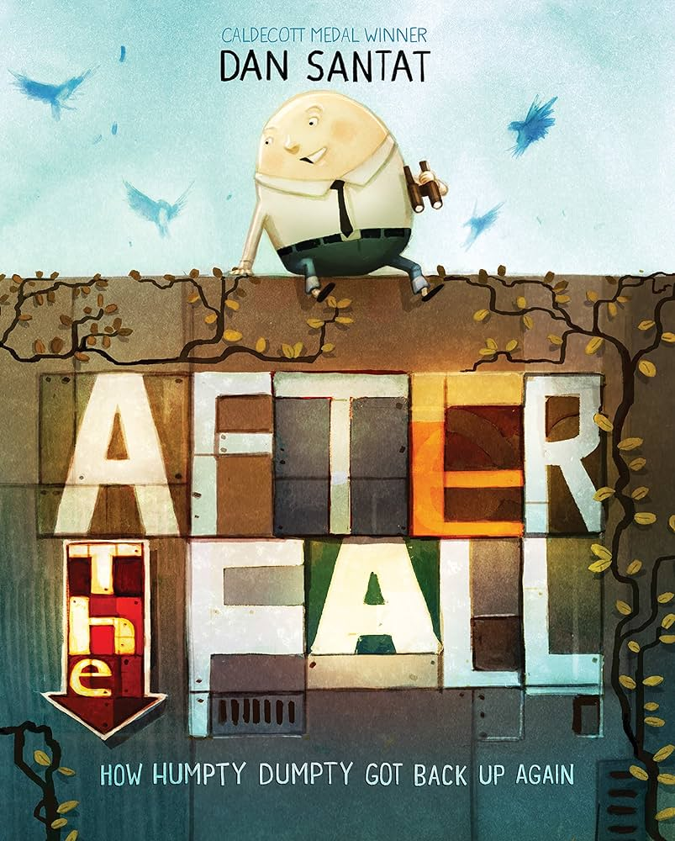 | Reading Learning Journey 2: (3 weeks)  Oliver Twist and Other Great Dickens Stories  by Marcia Williams.  Genre: Historical Fiction/Heritage  Themes: Rags to riches, heritage, good vs evil.  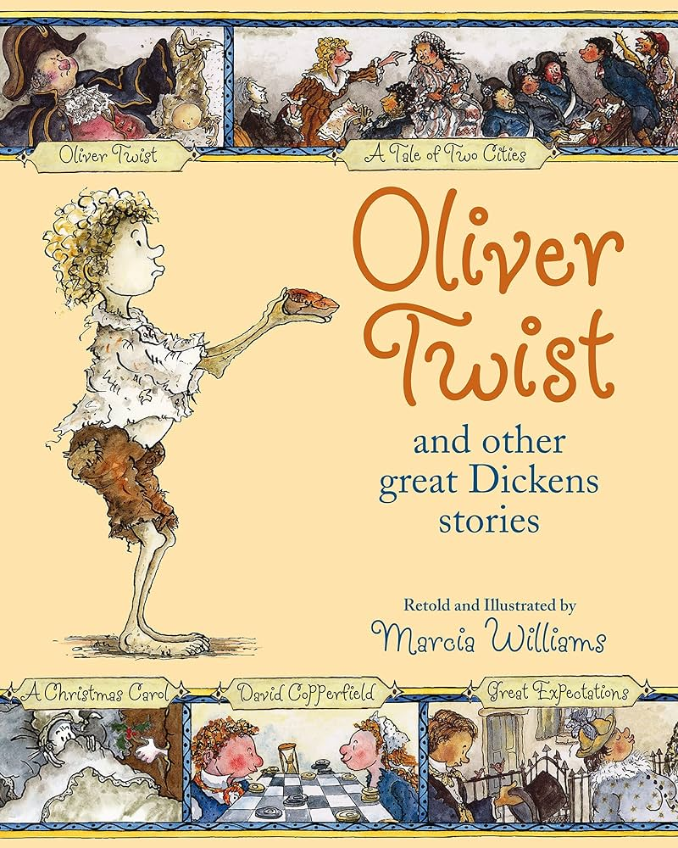 | Writing Learning Journey 2: (3weeks)  Fantastically Great Women Who Changed by Kate Pankhurst  Genre: Non-Fiction Biography)  Themes: Women’s rights, feminism, history, equality, justice.  Audience: Equal rights activists  Purpose: To educate  Form: Non – Chronological report  Effect: Respect  SOA: Setting Description  Trees.  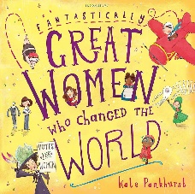 | Reading Learning Journey 2: (4 weeks)  Harry Potter and the Philosopher’s Stone  by J.K. Rowling  Genre: Fiction (fantasy)  Focus Skills:  Themes: Courage/ Heroism, Good vs. Evil  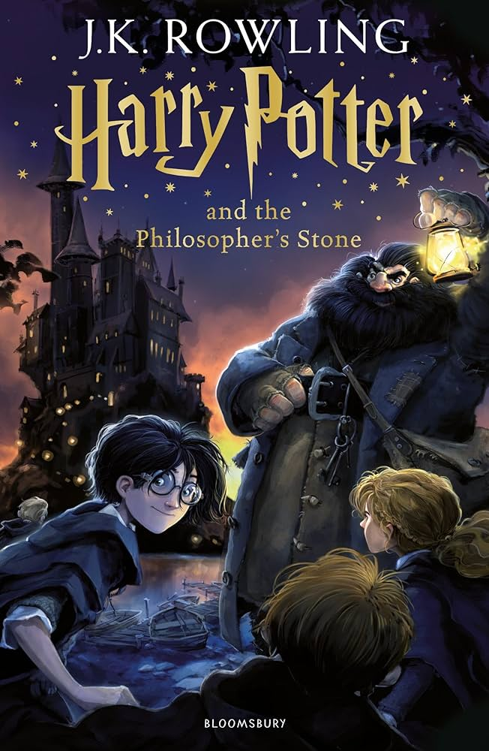 | Writing Learning Journey 2: (3 weeks)  Podkin One-Ear  by Kieran Larwood  Genre: Fantasy  Themes: Good vs evil, Heroism  Audience: Fans of the series  Purpose: To entertain.  Form: Recount  Effect: Readers are transported to the world of Podkin.  SOA: Non-chronological report (Gorm)  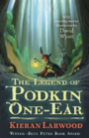 |  | Writing Learning Journey 2: (3 weeks)  Journey to the River Sea by Eva Ibbotson  Genre: Fiction  Themes: orphans, Amazon, friendship, family, courage.  Audience: Maia’s school friends.  Purpose: To learn what her experience has been so far.  Form: Narrative  Effect: A greater understanding of Maia’s experience.  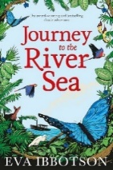  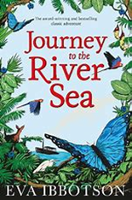  SOA: | Reading Learning Journey 2: (2 weeks)  The Great Kapok Tree  By Lynne Cherry  Genre: Fiction  Focus skills: Inference  Respond and Explain  Theme: Greed  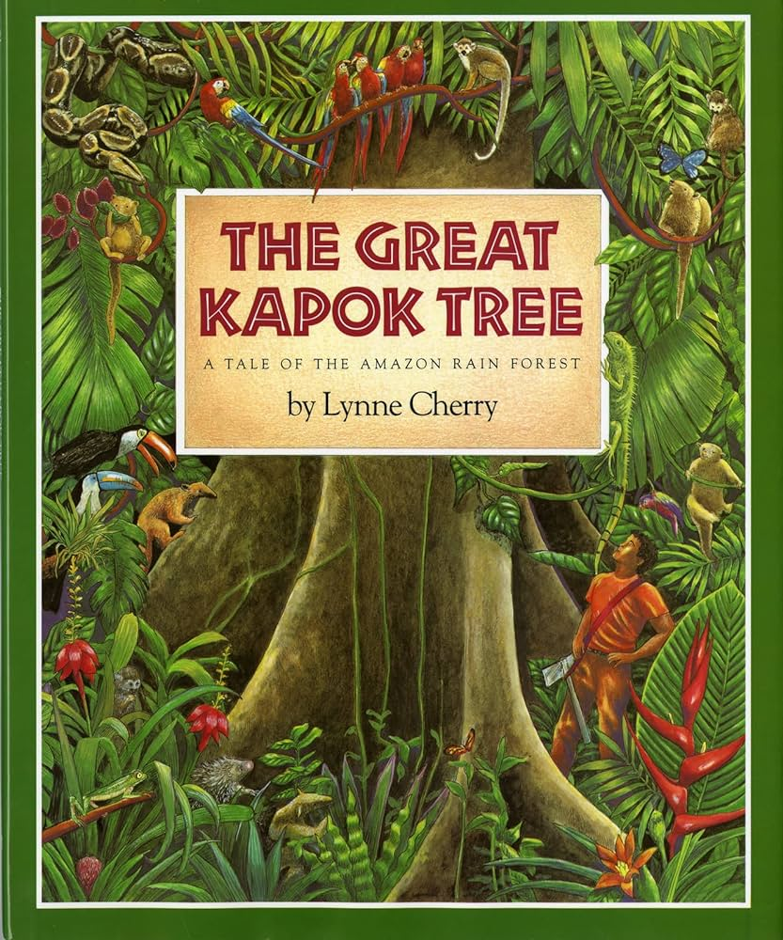 | Writing Learning Journey 2: (2weeks)  Percy Jackson and the Greek Gods  by Rick Riordan  Audience:  Purpose:  Form: Diary Entry  Effect:  SOA: | Reading Learning Journey 2: (3 weeks)  M is for Magic ’Instructions’ (short story)  by Neil Gaiman  Genre: Fiction (fantasy)  Focus skills: Clarify  Theme: Good vs evil, Heritage  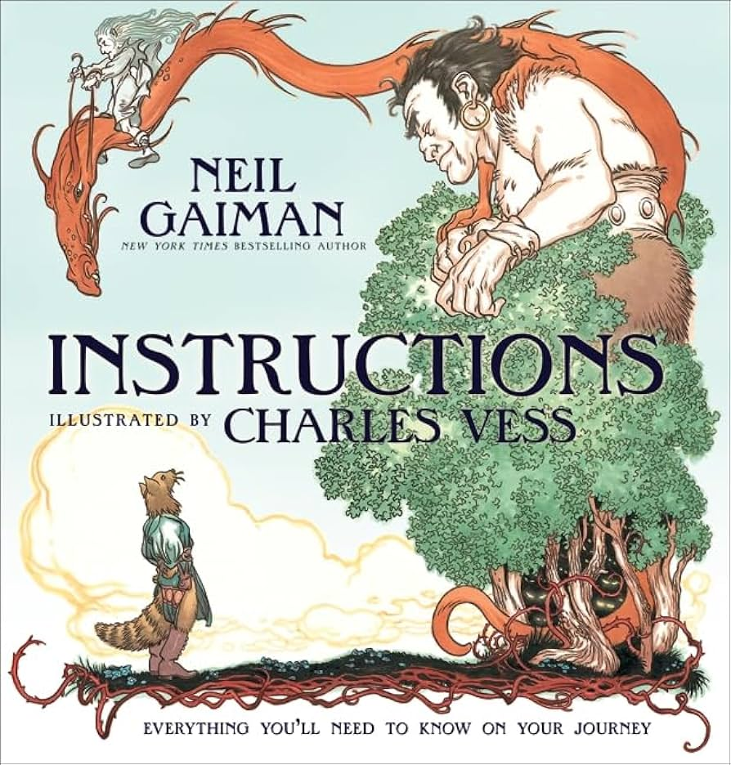 | Writing Learning Journey 2: (3 weeks)  Writing Learning Journey 2: (3 weeks)  by Robert Macfarlane  Genre: Poetry  Themes: Nature, figurative language, habitat/species loss.  Audience: Nature lovers  Purpose: To entertain  Effect: Readers will understand the animal at a deeper level.  Form: Poem  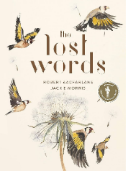 | Reading Learning Journey 2: (4 weeks)  Kensuke’s Kingdom  by Michael Morpurgo  Genre: Fiction  Focus skills: Inference, clarify  Theme: Survival, accepting differences  